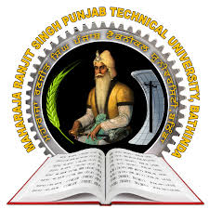
Maharaja Ranjit Singh Punjab Technical University
Badal Road, Bathinda -151001
(Established by Govt. of Punjab vide Punjab Act No. 5 of 2015)
wjkokik oDihs f;zx gzikp N?eBheb :{Bhtof;Nh, pkdb o'v, pfmzvk.

Ref. No.______________ Date : ______________
Directorate of Sports & Youth Welfare
Entry form for Inter-College Sports Competitions
Name of Institute ______________________________
Entry of Team ________________________________ (Men/Women)________
Refundable Security Amount of Rs. 2000/- Deposited (Yes/No)__________
Details of Sports fee paid to the University __________________________________________
_____________________________________________________________________________
Name of physical Education Teacher/Sports Officer ___________________________________
Mobile No. ________________________ E-Mail ID __________________________________
Name of Team Manager __________________________________________
Name of Team Coach ____________________________________________
Accommodation required –Yes/No _____ if Yes, then
(i) Total no. of players _______ (Male ____) (Female _______)
(ii) No of Team Inchargers_________ (Male ____) (Female ______)
(iii) Driver _________

Signature of DPE/Sports Officer

Date ______________ Signature of Principal/Director

